St just in bloom September 2023

  - Indian summer in full swing
Recent events
Third and final plant sale 2023
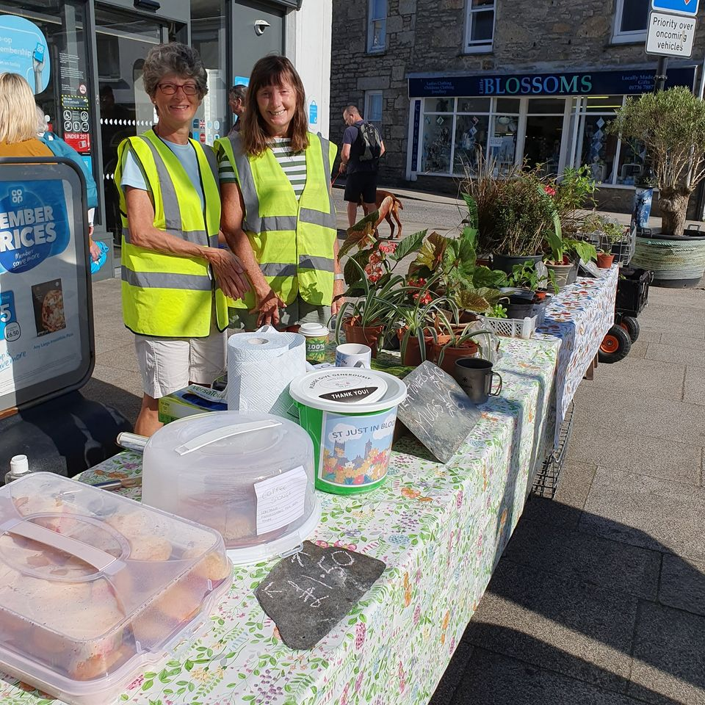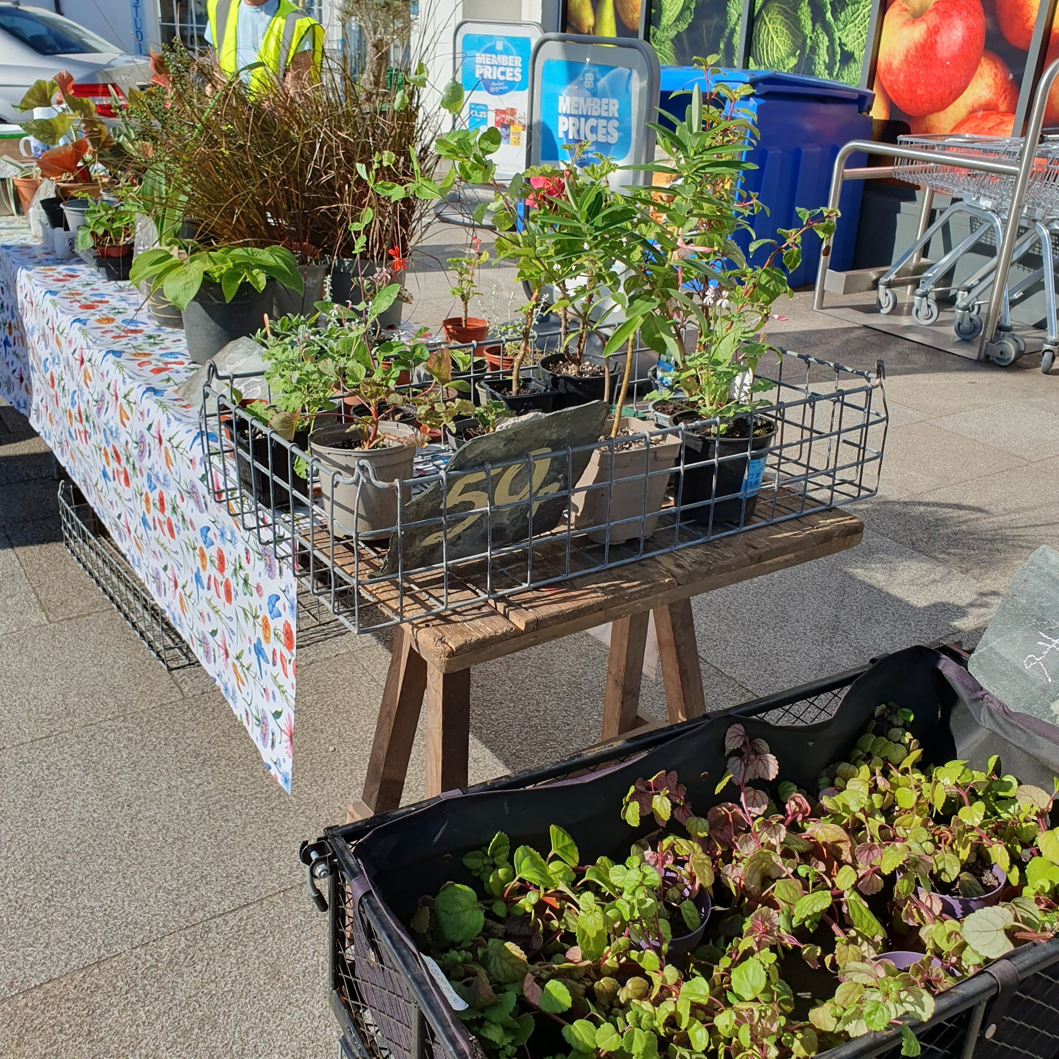
Gardening Competition 2023
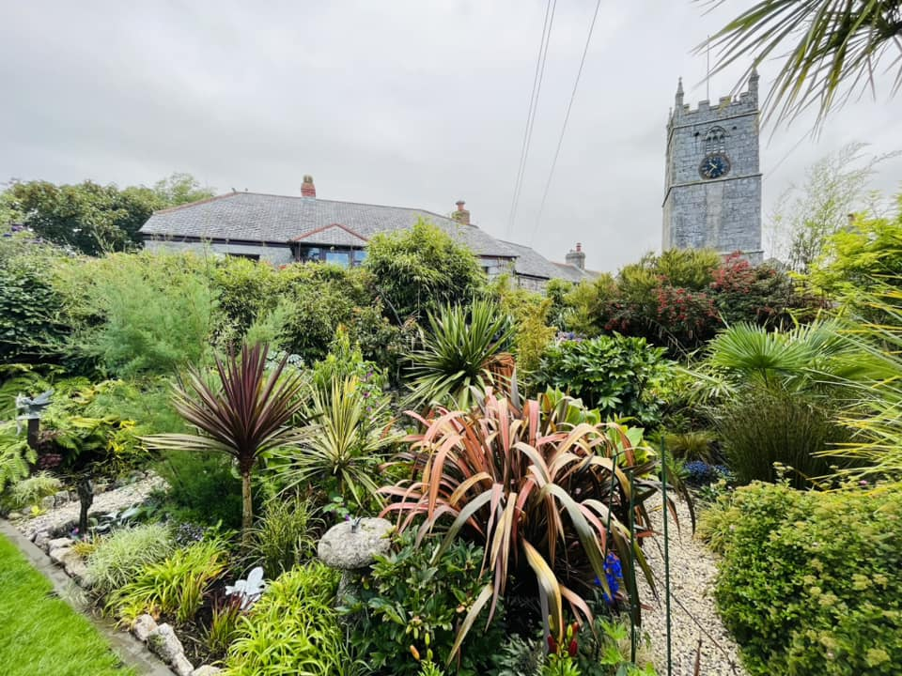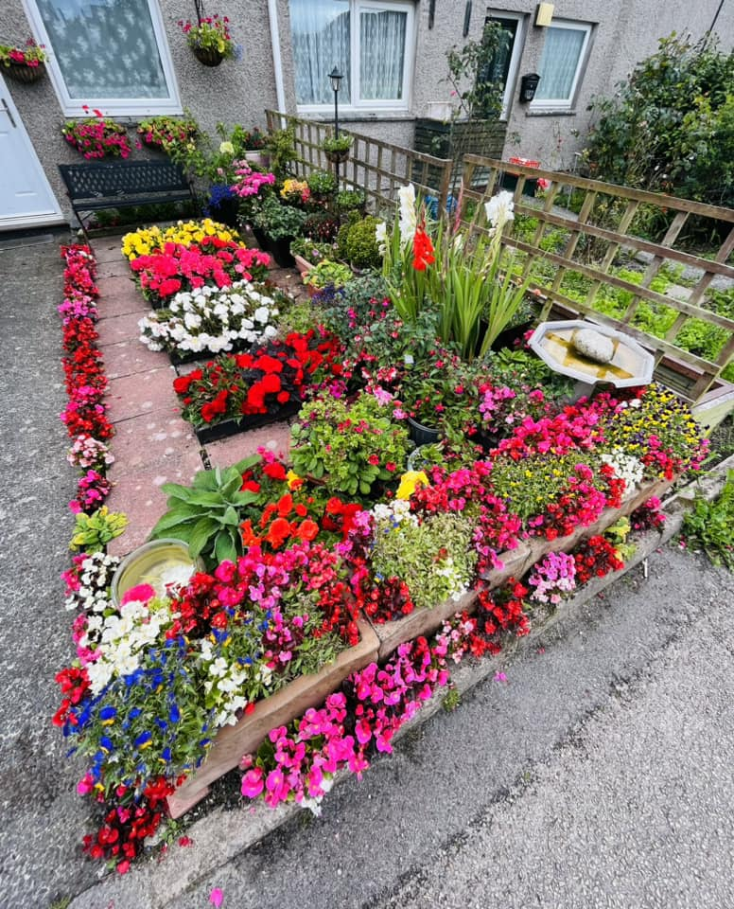
RHS Judging Day July 10th 2023
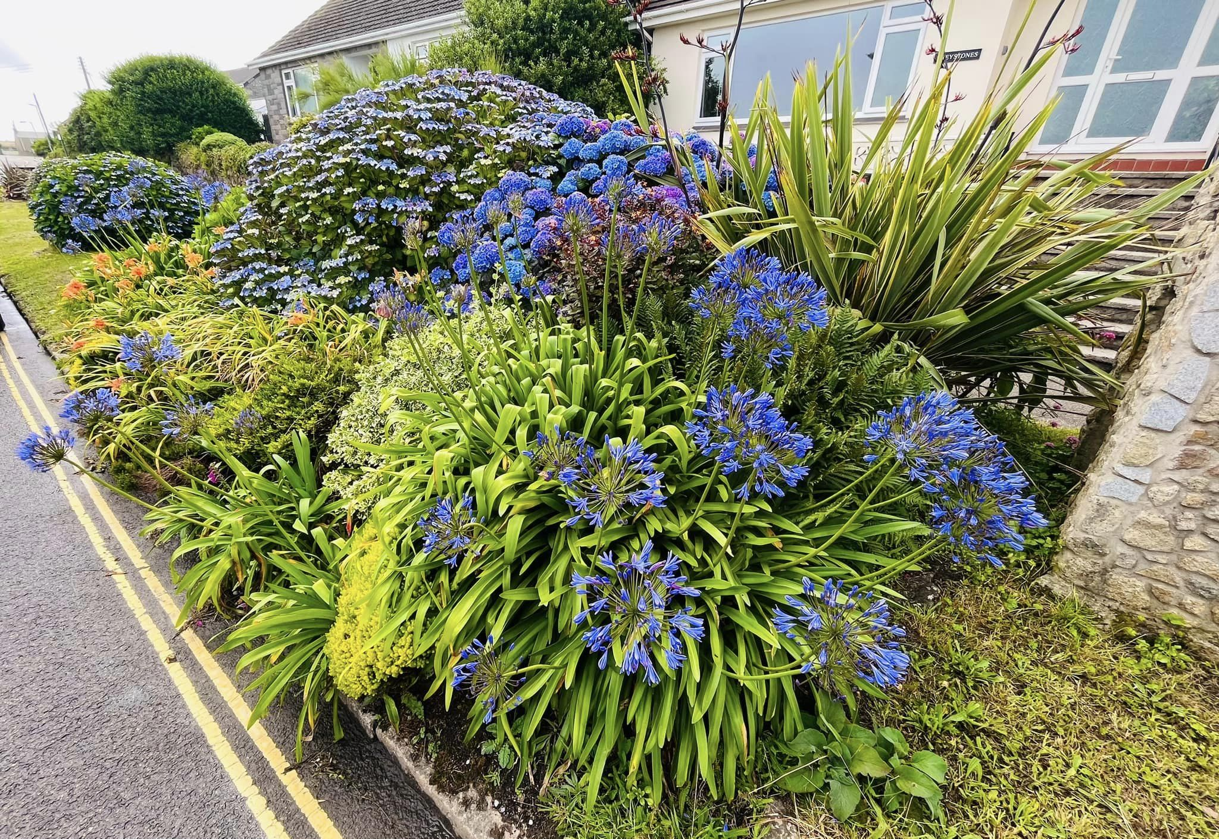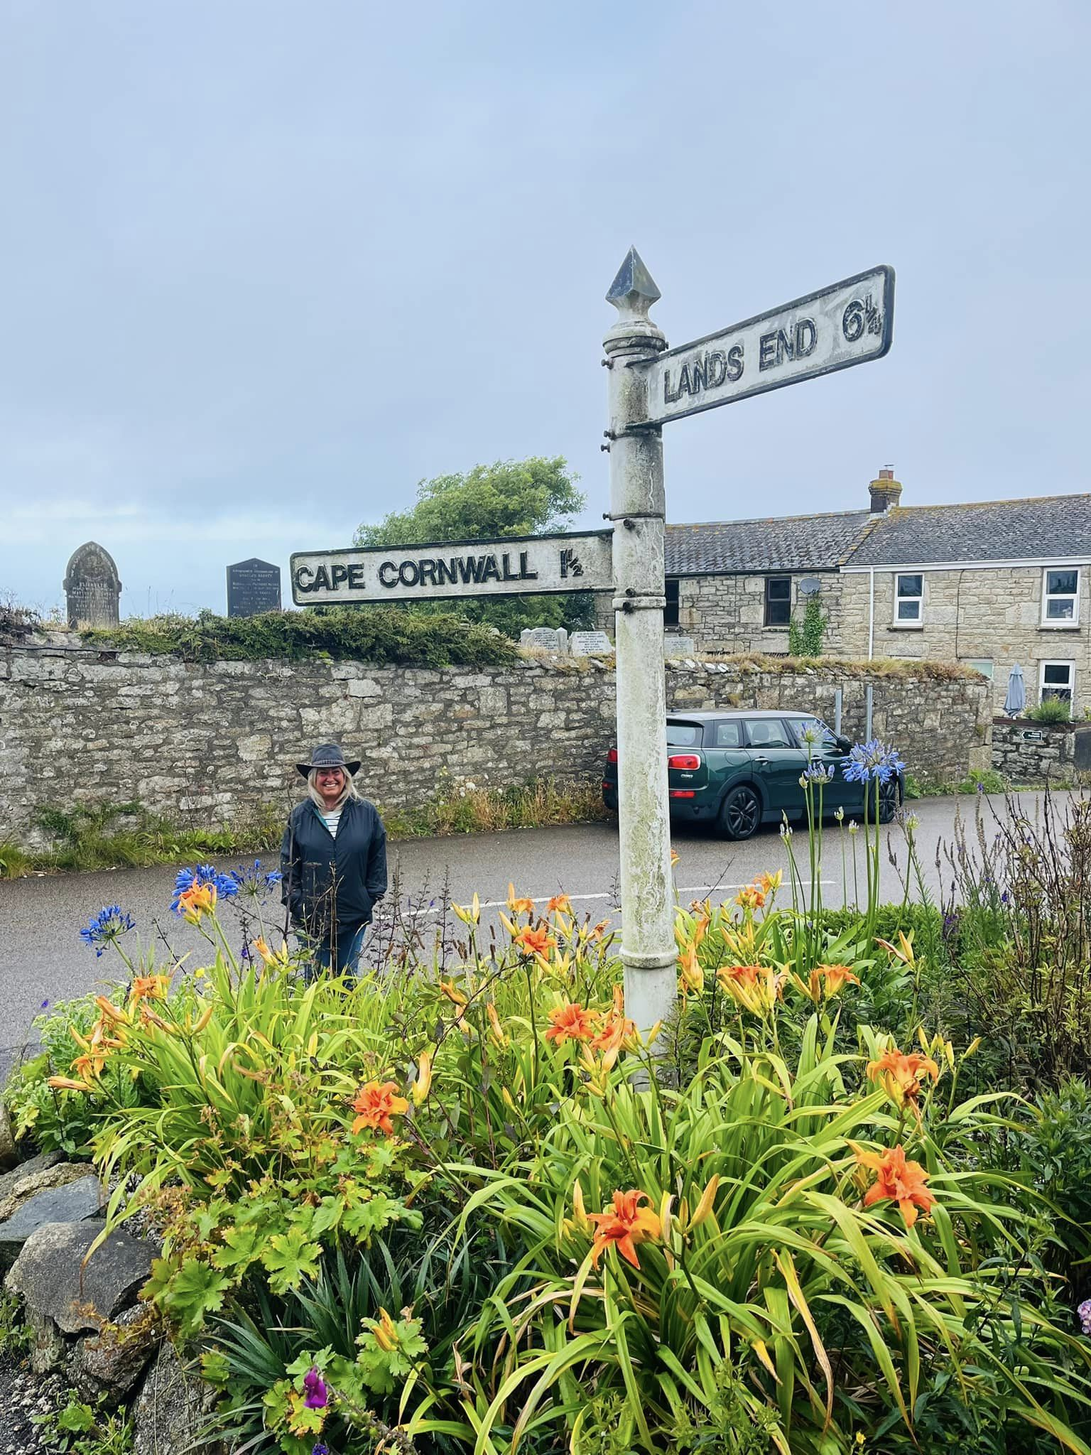
DATE FOR YOUR DIARY:
20th Anniversary and Awards Ceremony: 25th November 2023
St Just Old Town Hall

Contact Us
St Just in Bloom
GENERAL ENQUIRIES
info@stjustinbloom.org.uk
COMMITTEE ENQUIRIES
committee@stjustinbloom.org.uk

www.stjustinbloom.org.uk
find us on Facebook @stjustinbloom

After a somewhat disappointing August weatherwise, September has surprised us with soaring temperatures so far. The summer bedding is in its final flourish, but with the days beginning to shorten, Autumn is getting ready to join us.

News updates
WI Farmers Market Café – August 2023
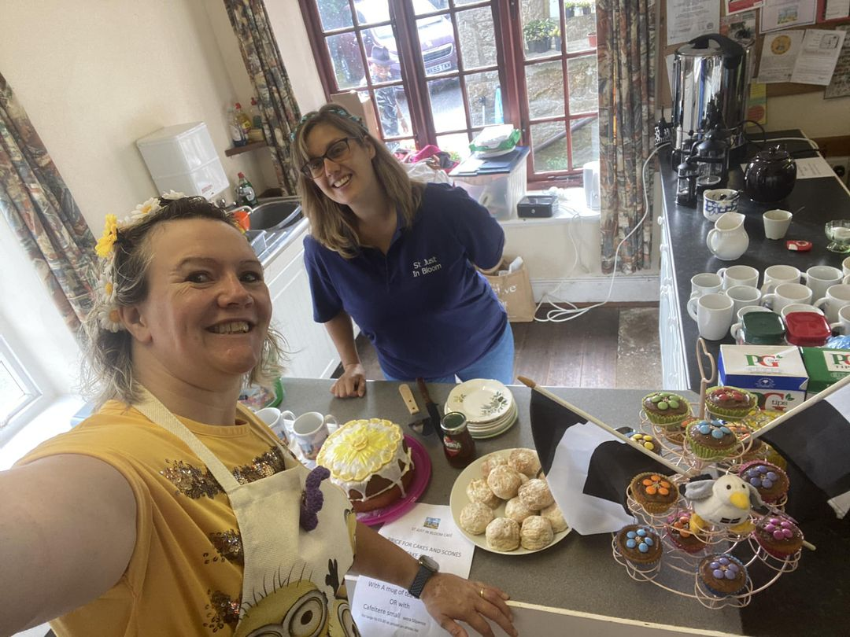
Another successful morning spent providing refreshment and entertainment to those visiting the weekly farmers market. Thank you to Hayley, Julie and Tamsyn that helped to run it and all those that baked all of the delightful cakes.

Plant pot recycling is underway!
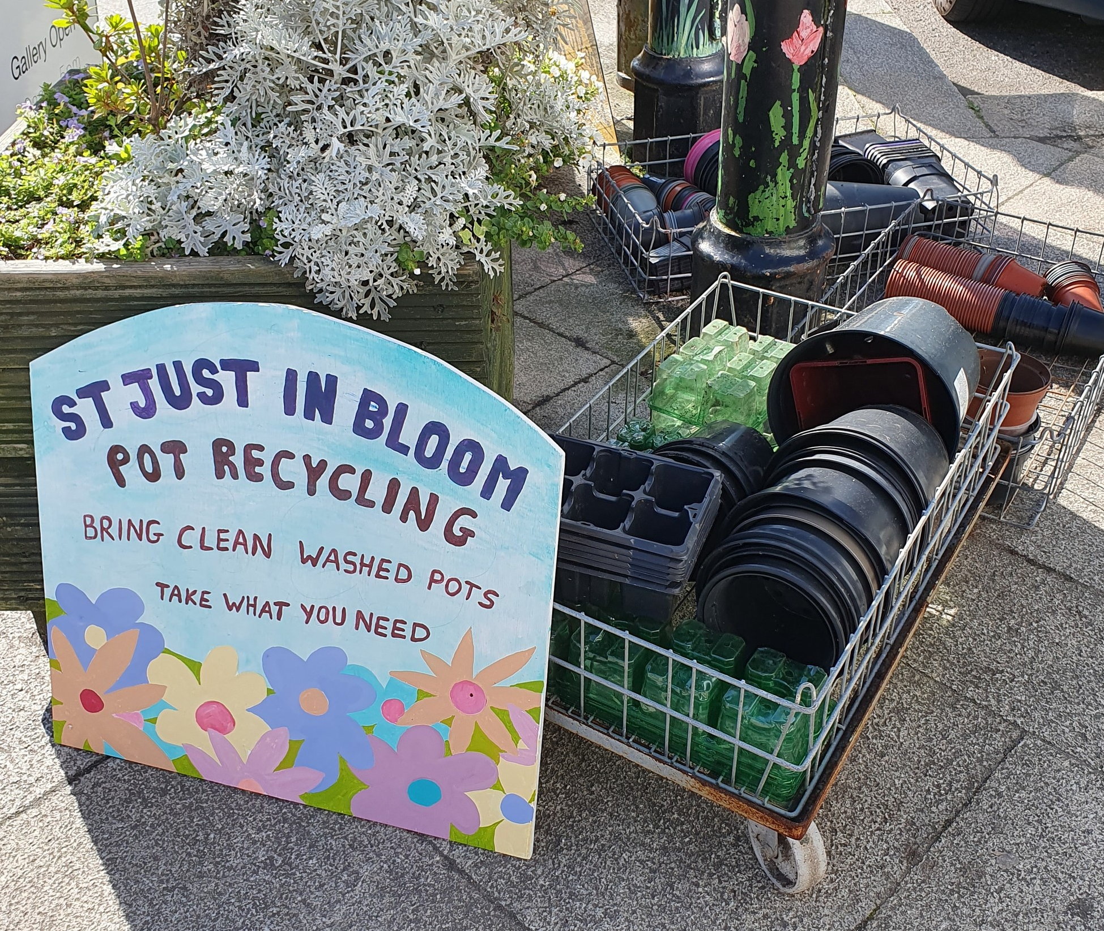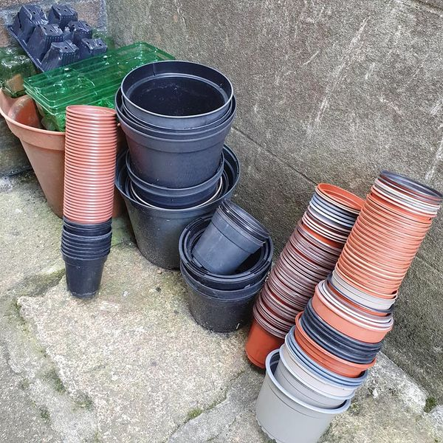
As the group aims to become even more sustainable, our new pot recycling scheme has begun. One of our volunteer members Suzy is running the show, and is exploring how the pots can either be passed onto other growers locally or taken for recycling into brand new pots! A drop off point can be found opposite the main parish church, though pretty please can all pot donations be cleaned beforehand.
Quiz night 2023
Despite having several other local events on the same evening, a lovely crowd joined Officers Julie, Phillipa plus Quiz master wonders Hayley and Tamsyn to take part in our annual fundraiser Quiz 2023. Congratulations to the winning team and everyone that came to enjoy a few laughs and some knowledge busting questions.
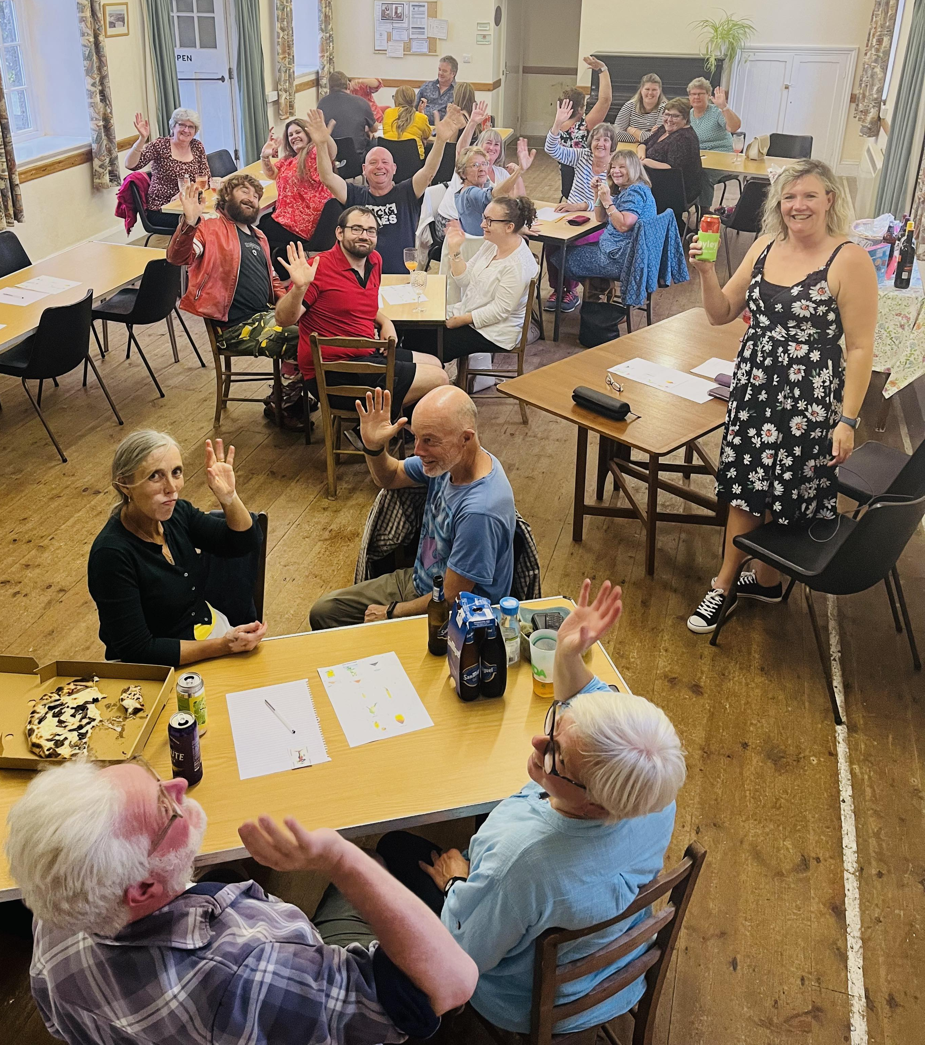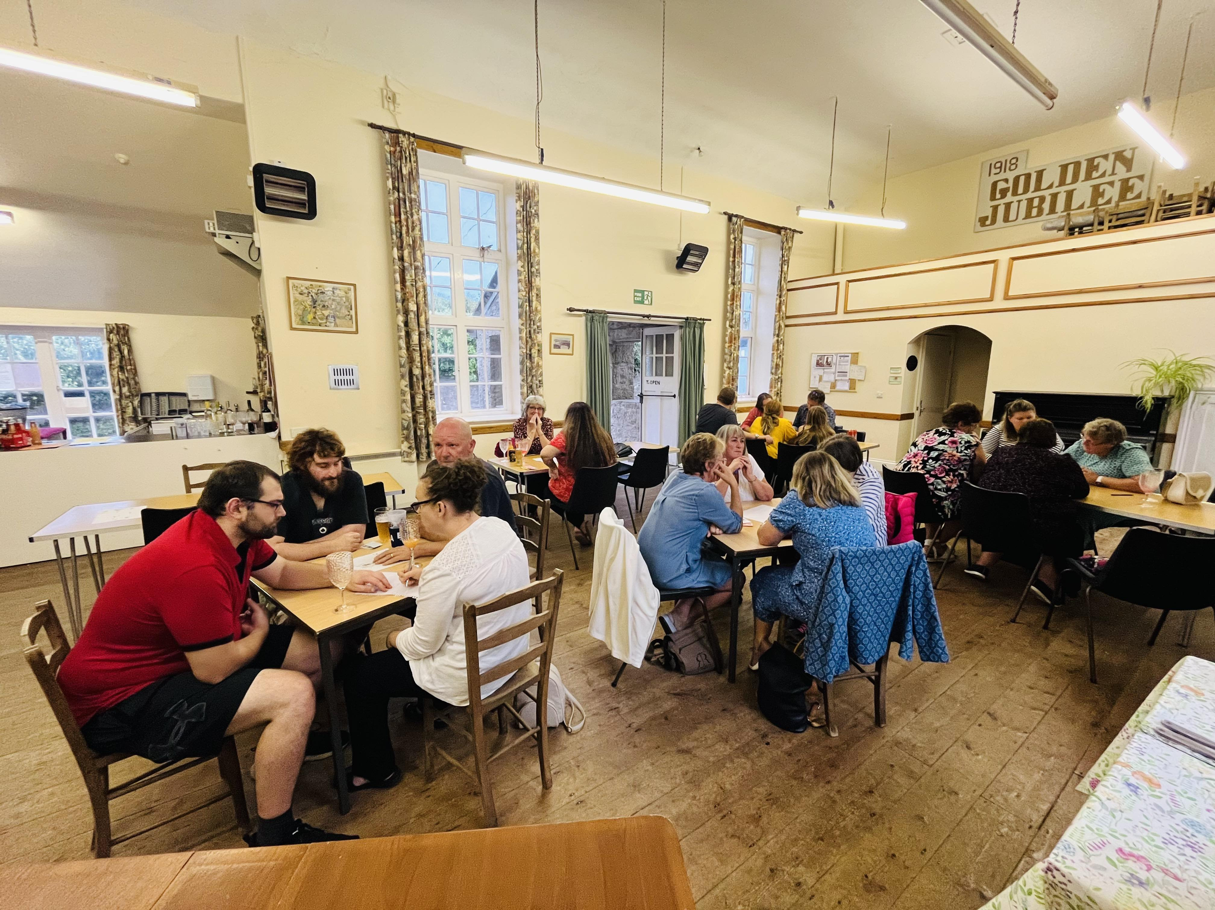
“Gardening: the fine art of soul to soil.” Jan Bills

Plots and jobs available
Plots:
- Kelynack Road Churchyard planters

Other tasks:
- General watering throughout the town – growing season
- Lafrowda carpark walls

We are always keen to increase our active members and so if you or anyone you know may enjoy working outdoors; watering, planting or fundraising, please do get in touch!

Finally thank you for the continued support from all the local businesses within the town, together we can keep St Just wonderful!
