St just in bloom mARCH 2023

  - Spring is on the way!
Recent events
Liam Shoesmith Talk
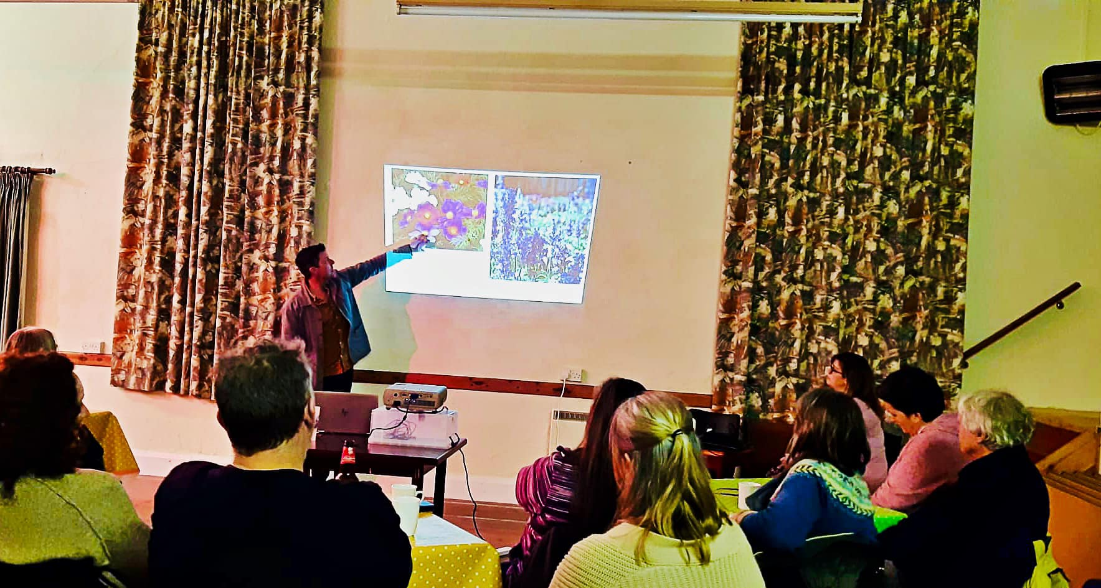
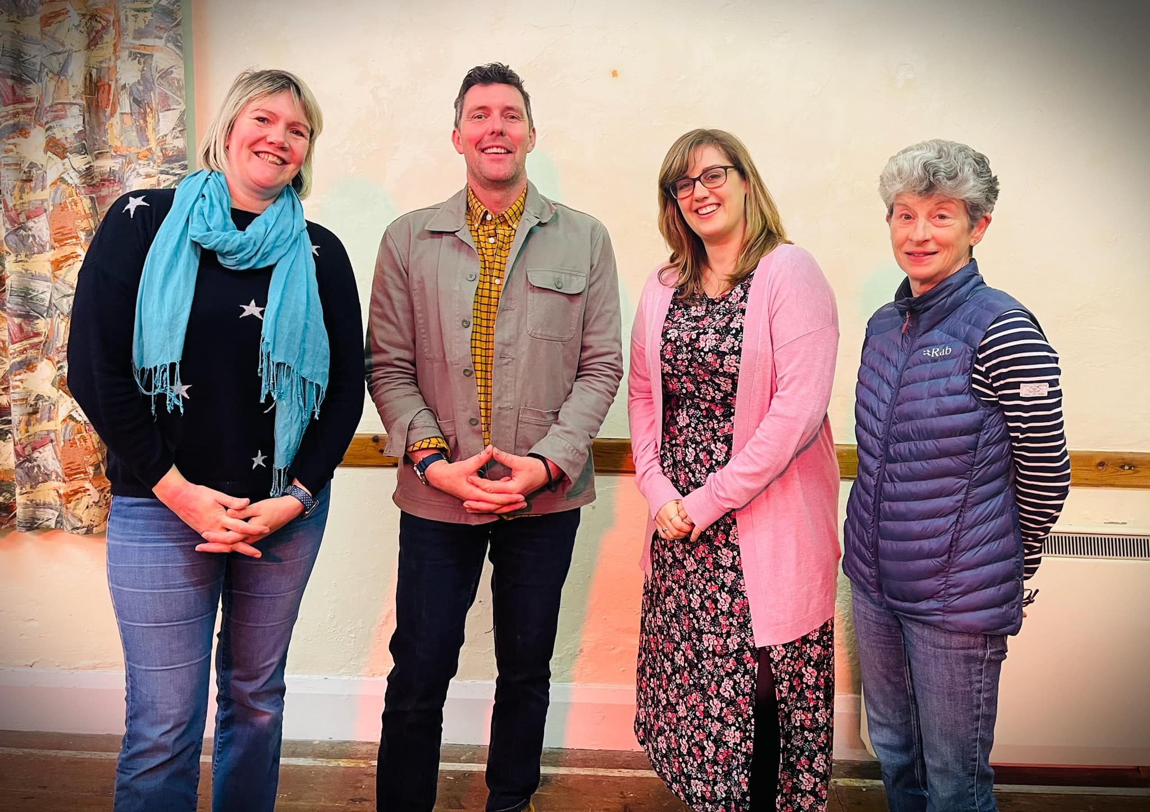

DATES FOR YOUR DIARY:
Plant and Cake Sale
Monday May 8th

Quiz Night
Friday 8th September
St Just WI Hall

Awards and Anniversary Event
Saturday 25th November
St Just Old Town Hall
DETAILS TO FOLLOW

Contact Us
GENERAL ENQUIRIES
info@stjustinbloom.org.uk
COMMITTEE ENQUIRIES
committee@stjustinbloom.org.uk

www.stjustinbloom.org.uk
find us on Facebook @stjustinbloom

  - As the days begin to get longer, we welcome the coming of Spring. Plants are starting to come to life and the first floral displays burst into view.
  - This means that the growing activities of the group are in full swing.
  - Seeds are being sown, cuttings nurtured and the plots prepared for the coming season.

  - 2023 is our 20th anniversary year, so we would like to celebrate in style, with limited edition merchandise, fabulous floral creations in the planning and a party extravaganza later in the year. So keep an eye on our Facebook page for all the updates.

  - 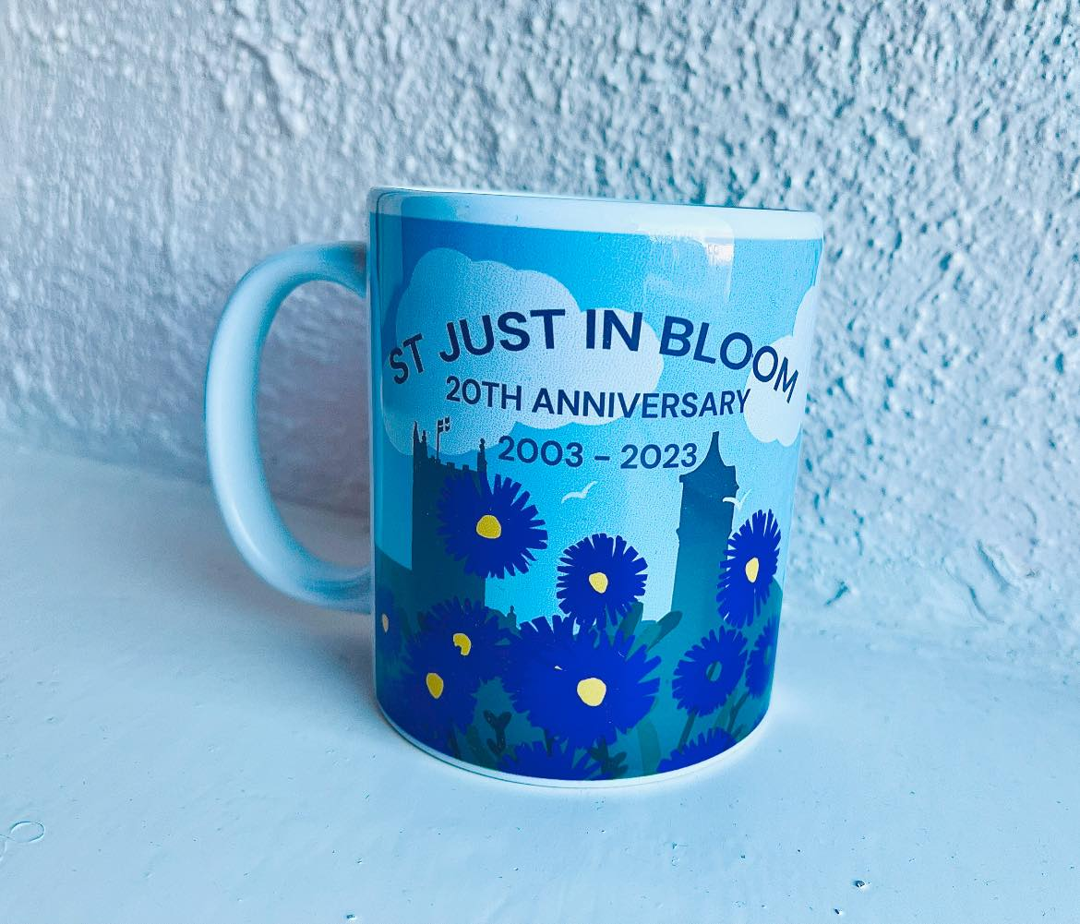

  - We made our first visit to the St Just WI Hall Farmers Market for 2023, with the flower squad Hayley, Julie and Tamsyn providing drinks and cakes with a smile. We also had our gorgeous mugs to sell and they went down a storm. Thank you to everyone that popped along to say hello and helped us to raise £147.71.

  - 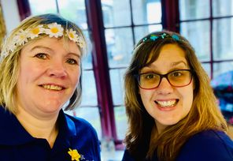

  - Back in February, Liam Shoesmith (BBC Radio Cornwall Garden line) joined us for a talk on Wildlife Gardening. He was a great sport and gave a really interesting talk. The night raised over £100 towards the group. We hope to organise further events this year, so watch this space!
  - Our Chair Tamsyn has also been exploring a range of grants that could be available to help the group with our work. We are thrilled to announce that Dobbies Garden Centre have shortlisted the group for a gardening equipment grant. The closing date for votes is 25th April 2023, so if you can, show your support! Fingers crossed we do well!
  - St Just Town Council have kindly supported us again this year, by assisting us with the cost of new additional plants, the tiered planters and new compost for the existing planters. We are extremely grateful for this, as it makes a huge difference. We hope the displays we create will make the town look even more fantastic.

“Bloom where you are planted” Unknown author

Plots and jobs available
Plots:
- Carn Bosavern beds
- Lafrowda car park walls

Tasks for Spring:
- Bench cleaning and oiling
- Deadheading daffodils – leaving foliage intact

We are always keen to increase our active members and so if you or anyone you know may enjoy working outdoors; watering, planting or fundraising, please do get in touch!

Finally thank you for the continued support from all the local businesses within the town, together we can keep St Just wonderful!
