St just in bloom December 2022

  - 2022, What a Year!
Recent events
Remembrance 2022
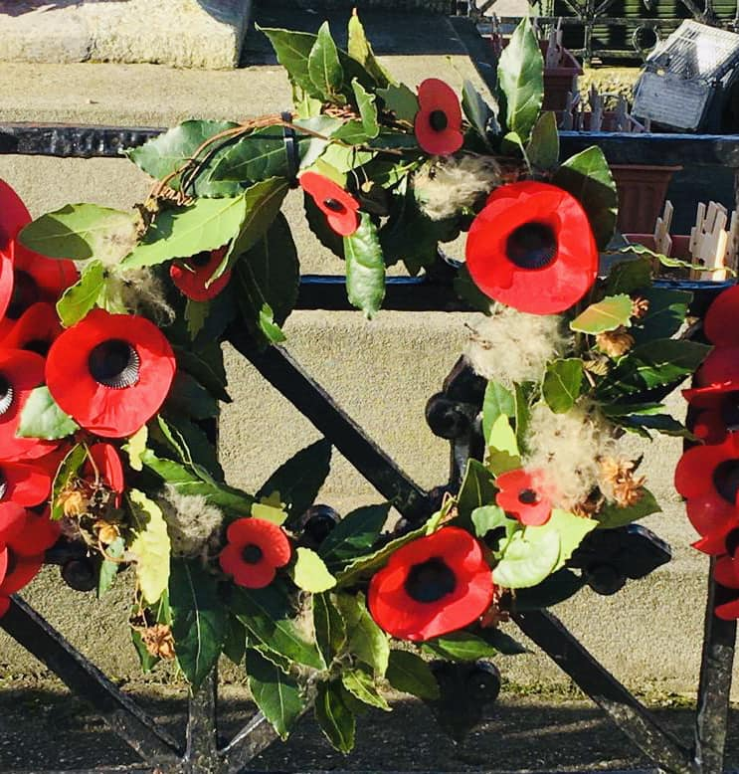

Christmas Tree Festival 2022
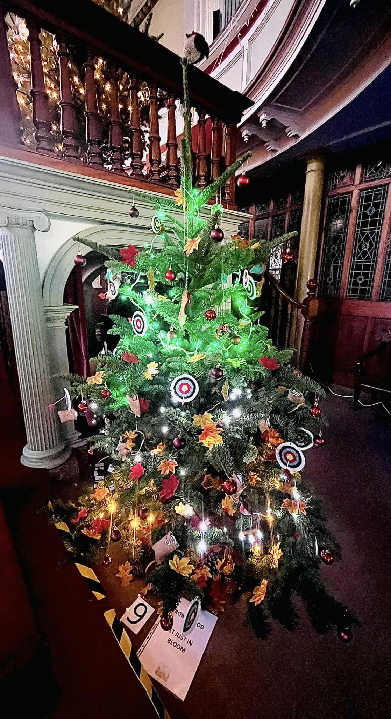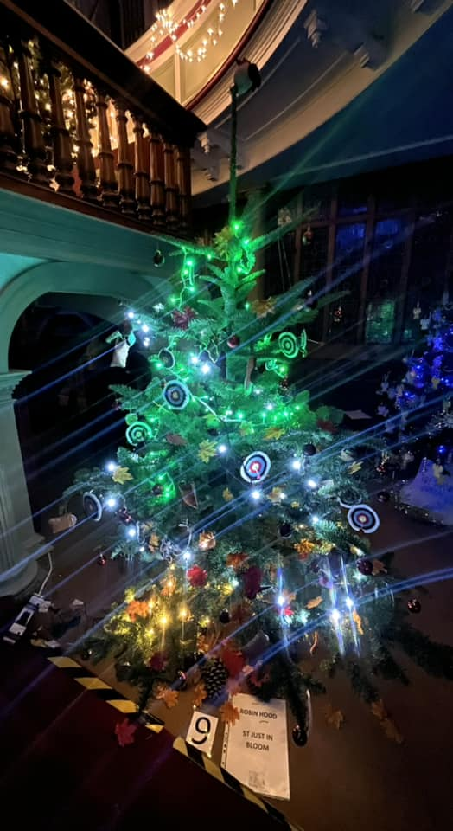

DATE FOR YOUR DIARY:

IYN Awards and Meeting
The Star Inn
Wednesday 11th January
7pm
Please bring along a plate of food to enjoy.
Thank

Contact Us
St Just in Bloom
GENERAL ENQUIRIES
info@stjustinbloom.org.uk
COMMITTEE ENQUIRIES
committee@stjustinbloom.org.uk

www.stjustinbloom.org.uk
find us on Facebook @stjustinbloom

  - Merry Christmas and Happy New Year from everyone in St Just in Bloom.
  - 2023 is a big year for our group, as it is our 20th anniversary and we plan to celebrate in style!

  - Our annual AGM was held in November and we are thrilled to announce our new Committee officers. After working tirelessly to lead our group, Holly Whitelaw has taken the decision to step down as Chair. Thank you Holly for all you have achieved for the group. Our new committee officers are seen below:
  - New Chair: Tamsyn Casley-Oliver
  - New Vice Chairs: Phillipa La Fontaine and Hayley Stringer
  - Treasurer: Maureen King
  - Secretary: Julie Towers
  - We wish them all the best in their roles in the coming months.

  - The WI Farmers’ Market invited the group to provide refreshments on several occasions and it has been a great opportunity to engage with our wonderful community. Plus we have had some of our lovely mugs to sell!
  - 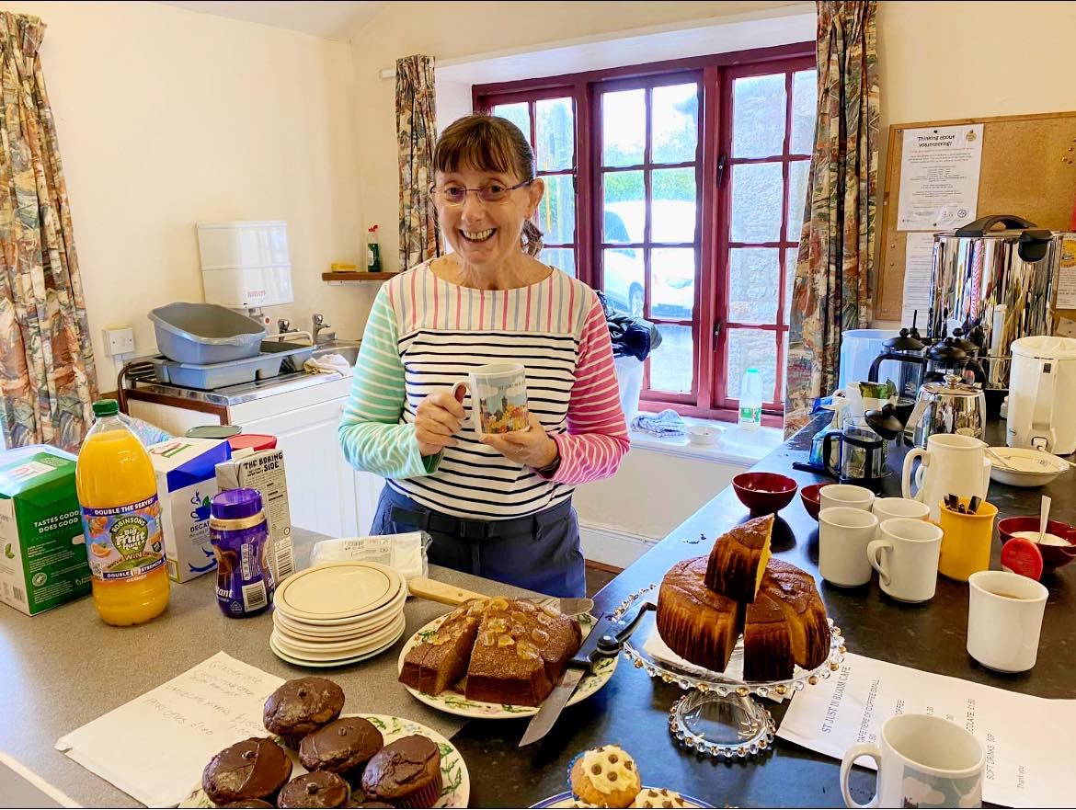

  - In November, a collaboration event took place between SJIB and Cape Cornwall Scout Group. A team of enthusiastic youngsters and volunteers Tamsyn and Phillipa headed to the Closed Churchyard to clear a large area of brambles. This has helped to reveal several graves and encourage native primroses to thrive. It was hard work but exceptionally rewarding!

  - 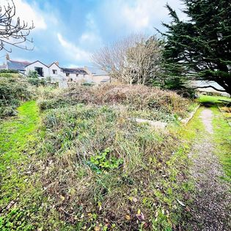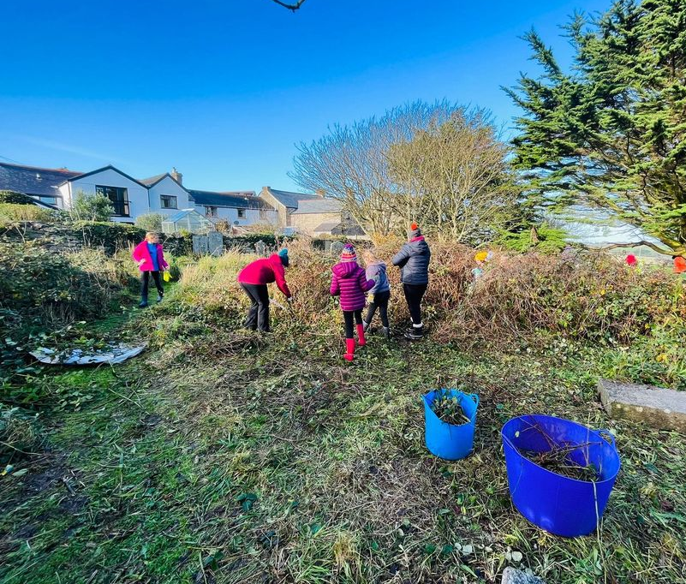
  - In December, we worked with Ali Law from Wild West Flowers to run a Wreath Making Workshop at the St Just WI Hall. The mulled wine was flowing, as well as the creativity. What a better way to have spent a winter’s evening preparing for the festive season.

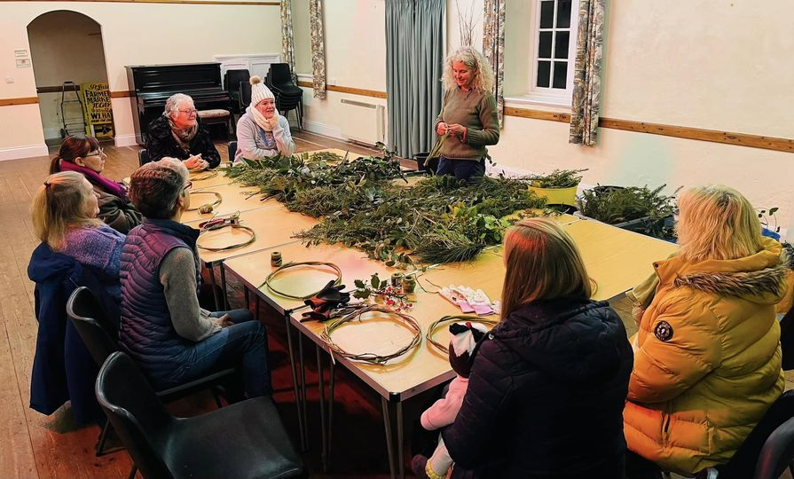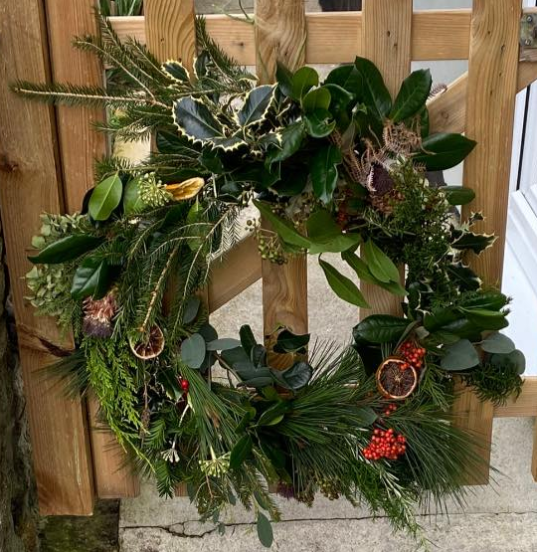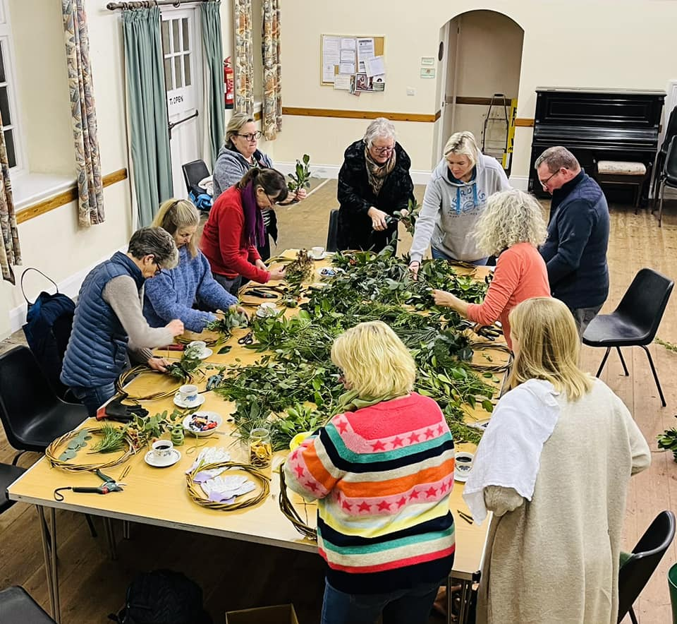

“A garden is not a place, it is a journey” Monty Don

Plots and jobs available
Plots:
- Carn Bosavern beds
- Bank Square planters

We are always keen to increase our active members and so if you or anyone you know may enjoy working outdoors; watering, planting or fundraising, please do get in touch!

Finally thank you for the continued support from all the local businesses within the town, together we can keep St Just wonderful!
